**Main Components**

* 8051 microcontroller
* Bluetooth Module HC05
* Relay
* ULN2003
* Bulb
* Holder
* Wire
* IC 7805
* Android phone
* Bluetooth controller app Android app
* 10uf capacitor
* 1000uf capacitor
* 10K resistor
* 1k resistor
* Power Supply

**How to operate Bluetooth module?**

You can directly use the Bluetooth module after purchasing from market, because there is no need to change any setting of Bluetooth module. Default baud rate of new Bluetooth module is 9600 bps. You just need to connect rx and tx to controller or serial converter and give 5 volt dc regulated power supply to module.

Bluetooth module has two modes one is master mode and second one is slave mode. User can set either mode by using some AT commands. Even user can set module’s setting by using AT command. Here is some commands uses are given:

First of all user need to enter AT mode with 38400 bps baud rate by pressing EN button at Bluetooth module or by giving HIGH level at EN pin. Note: all commands should ends with \r\n (0x0d and 0x0a) or ENTER KEY from keyboard.

After it if you send AT to module then module will respond with OK

AT → Test Command

AT+ROLE=0 → Slave Mode select

AT+ROLE=1 → Master Mode select

AT+NAME=xyz  → Set Bluetooth Name

AT+PSWD=xyz → Set Password

AT+UART=<value1>,<value2>,<value3>  → set Baud rate

Eg. AT+UART=9600,0,0

**Pin Description of accelerometer:**

1. STATE  → Open
2. Rx  → Serial receiving pin
3. Tx  → Serial transmitting pin
4. GND   → ground
5. Vcc     → +5volt dc
6. EN       → to enter in AT mode

**Working Explanation:**

In this project we have used8051 microcontroller for controlling the whole process of this project. And a Bluetooth module is used for controlling the home appliances wirelessly. Home appliances will turned ON and OFF when user will touch button in the Bluetooth mobile app in Android mobile phone. To run this project, first we need to download Bluetooth app form Google play store. We can use any Bluetooth app that can send data using Bluetooth. Here are some apps name that can be used:

1. Bluetooth app pro
2. Bluetooth controller

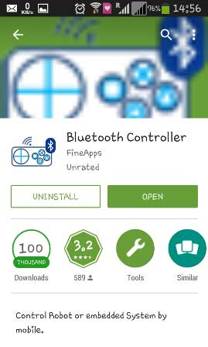

After installing the App, you need to open it and then search Bluetooth device and select HC-05 Bluetooth device. And then configure keys.

Here in this project we have used **Bluetooth controller app**.

1. Download and install Bluetooth Controller.
2. Turned ON mobile Bluetooth.
3. Now open Bluetooth controller app
4. Press scan
5. Select desired Bluetooth device (Bluetooth Module HC-05).
6. Now set keys by pressing set buttons on screen

To set keys we need to press ‘set button’ and set key according to picture given below:

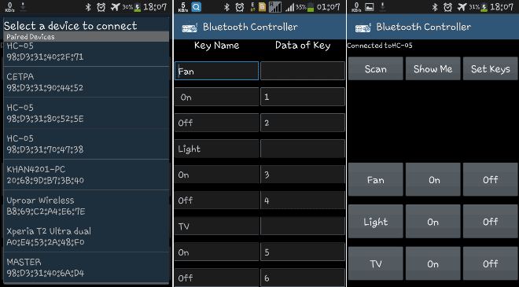

After setting keys press ok.

You can see in the above picture that there are 9 buttons in which first row is for fan controlling, second one is for light controlling and last one is for TV controlling.  Means First row’s ON and OFF buttons are used to ON and OFF the fan, second row’s buttons are for Light and third ones are for TV. We have used three bulbs of different colors instead of TV and fan, for demonstration purpose.

Now, when we touch any button in Bluetooth controller app then Android phone sends a value to Bluetooth module, after receiving this value, Bluetooth module sends the received value to the microcontroller and then microcontroller reads it and compare it with predefined value. If any match is occurred then microcontroller performs relative operation. Same operation will performed each time when button pressed.

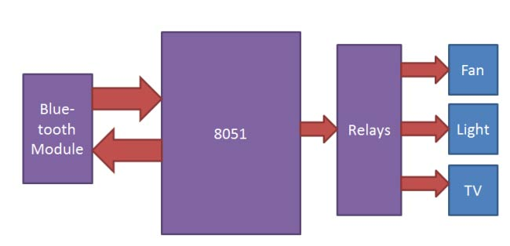

Now, when user touch ‘Fan On’ button in Bluetooth controller app then microcontroller receives ‘1’ via Bluetooth module and then controller Switch ‘On’ the Fan by using relay driver and relay. And when user touch ‘Fan Off’ button in Bluetooth controller app then microcontroller receives ‘2’ via Bluetooth module and then controller Switch ‘Off’ the Fan by using relay driver and relay.

Likewise 3,4,5,6 numbers are sent by Android Phone, when Light On, Light Off, TV On, TV Off button has been touched respectively:

**CIRCUIT:**

